# Graphic Design Documentation

## The Pashe Kosh

Start of project: June 24, 2020

Logo: The Pashe Kosh

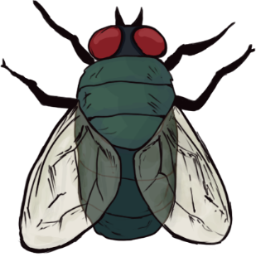

## Version: 1.0.0

### Written by

### SadeQ Soli & Ebrahim Gholami

a game production by



# Design History

## Version 1.0.0

May 24, 2020 to Aug 01, 2019

Version 1.0.0 is the creation of this game design documentation (GDD). The basic framework of the documentation is created so that more information can be included more efficiently, with each section labeled. The content page is created as well.

# Overview

## Category

* Hyper-Casual

## Theme / Genre

* 1 – Arcade

## Features

* 1 - 2D game
* 2 - Arcade-Game
* 3 - Single Player
* 4 - Fixed Camera view
* 5 - Dynamic music and feedback
* 6 - Visual Feedback

## Targeted platforms

* 1 - Android Platform
* 2 - iOS Platform
* 3 – Html5

## Intended Audience

The intended audience of this game is primarily for both genders from the age range of 3 years of age and above. The language of the game does NOT contain any inappropriate language and therefore, the audience could be 3 years of age or above.

## Language

* 1 - English
* 2 – Persian

*There is no aggressive, dirty, or inappropriate language is used in this game.

## Sound Consideration

The game play experience of this game depends very much on the music. In this game, we will be including sounds such as the main music for the levels, sound scaping, audio feedbacks, and interface and in‐game sound effects.

## Project Scope

Project Time Scale

So when this journey began at May 24, 2020 . We believed that we will ready to present at “ July 1st , 2020 “ at persian market.

**Team Size**

**Core Team (Perfect Team)**

* Project Manager / SadeQSoli
* Graphic Designer / Mikael Hamedi
* Programmer / Ebrahim Gholami & SadeQSoli
* Game Designer / Samira Soltani
* UI/UX / SadeQSoli / Mikael Hamedi
* Animator / Ebrahim Gholami SadeQSoli
* Sound & Music / Out sourced

**Marketing Team**

* Head of Marketing / Erfan Rezaei

Licenses

* License 1 / We didn’t have any licensed asset.

Hardware

* Hardware / We didn’t have any licensed asset.

Other Costs

* Other Costs / We didn’t have any licensed asset.

## The elevator Pitch

We as a group of dreamers create what we love with modifications to make it more desirable if it were reality. Making new conception would be our main aim when it comes to creating playful games for people of all walks of life. Hopefully, our activities would push the limits whether be it in our mind or in our world.

# Gameplay

## Gameplay (Brief)

This is a hyper-casual game that uses tap timing + tap in place. Story is about a piece of cake or food that is under attack from (fly) Pashe and player should defend this target with swatter and kill them all.

## Gameplay (Detailed)

<Go into as much detail as needs be>

<Spare no detail>

<Combine this with the game mechanics section above>

# Story

Outline

Story is about a piece of cake or food that is under attack from (fly) Pashe and player should defend this target with swatter and kill them all.

# Core Gameplay Mechanics (Detailed)

## Core Gameplay Mechanic #1 – Camera

There will be a fixed camera. The camera does not move at all throughout the game.

## Core Gameplay Mechanic #2 – Single Player

In this game, the player controls the main ship. This game is meant for a single player playing experience.

## Core Gameplay Mechanic #3 – Player Defense Option

The player can use taping system that has been implemented to kill the insects that wanted to eat the food at the center of table(screen).

## Core Gameplay Mechanic #4 – Initial Setup

The food is going to spawn at starts at the center of screen and the NPCs (insects) are being spawn at starts at the every direction of screen. As time goes by game difficulty goes higher as you’ll see in the table in the Time-stage difficulty section, the speed, health and ability to dodge swatter is different. Depending on the Time-stage, “Powerups” and “Power downs” might be spawned as well.

## Core Gameplay Mechanic #6 – Health

The Player’s health is depends on the food at the center and if the food is ruins player will lose too.

## Core Gameplay Mechanic #7 – Low / Critical Health

When the player’s health reach 75% and below, health bar icon will be a little brighter than 100% and the sound of heart beats is played and When the player’s health reach 50% and below, health bar icon will be a little brighter than before and the sound of heart beats is played faster and When the player’s health reach 25% and below, health bar icon will be a little brighter than before and the sound of heart beats is played even faster. This signals to the player that the food is in low health. to signify to the player that the health has reached a critical stage. The player will lose when its health reaches 0% and Game over panel will be displayed.

## Core Gameplay Mechanic #8– Moving Objects

There are 3 kinds of objects that will move within the game.

They are namely the:

1. Candy

→ Player can trick insects to get candy and kill them while their at it.

3. Powerup

→ Collect in order to Gain an special “ Power ” for certain amount of time.

4. Power Down

→ DON’T Collect these to Stay safe and continue to avoid them at any time.

## Core Gameplay Mechanic #9 – Powerup

Powerup number 1

When the ship has collision with this magic candy the ship size will be twice before and the canon ball’s speed will be twice faster for 15 second and the sound of Magic candy will be played.



## Core Gameplay Mechanic #10 – Power Down

Power Down

When the ship has collision with this Junk candy, 2 child ship will be spawn at the top of screen and if you don’t destroy them, they will be spawn again at the top of screen and the sound of Junk candy will be played.



## Core Gameplay Mechanic #11 – Collision Between Objects

Player Swatter with Insects

When the player’s swatter hits the Insects, if there is a easy insect it will be explode and the sound of explosion will be played but if there is different kind of insect it might two or more needed.

Insects with The Food

When insects reaching the food they have a certain amount of time to ruin the pieces of the food and when they do the piece will be disappear after few second.

## Core Gameplay Mechanic #12 – Deactivating Objects

Crossed Objects

There is 4 deactivator one at the top, out of screen and one at the bottom, right and left to deactivate Crossed objects that going out of screen in any direction.

## Core Gameplay Mechanic #13 – Scoring System

Scores

Scoring system will be on the time that has been passed before the food ruins completely. You can top that every time by using correct equipment and resources.

Energy

This will be for the time that player use swatter too much at time or in a row, energy will go down for a second or two.

Candy

Candy system will be on collecting only in this game, you can NOT exchange anything in-game to get more Candy. Candies are exclusively designed use in current game only. Of course, Player can buy Candy in by viewing the Ads.

* + There is no grading system, for simplicity of game.

## Core Gameplay Mechanic #14 –Status Trigger

**Communication Triggers**

When the player does something wrong, the game will communicate failure to the player. Communication system will display visual and audio feedbacks to the player in terms of failure, either positive or negative ones depending on the state.

Win / Game Over Screen Statistics

When the player loses, they will be brought to a Game Over screen. If the player wins in any level, they will be brought to the same winning screen but there is a bonus screen that it comes before winning screen . . The following is a list of statistics to be displayed on the screen in the Win / Game Over screen.

TODO: Picture of Win/Game Over Screen.

Interface Flowchart

This is an expanded flowchart from the main game play screen to the end of level 3, showing the in between screens that are missed in the previous one.

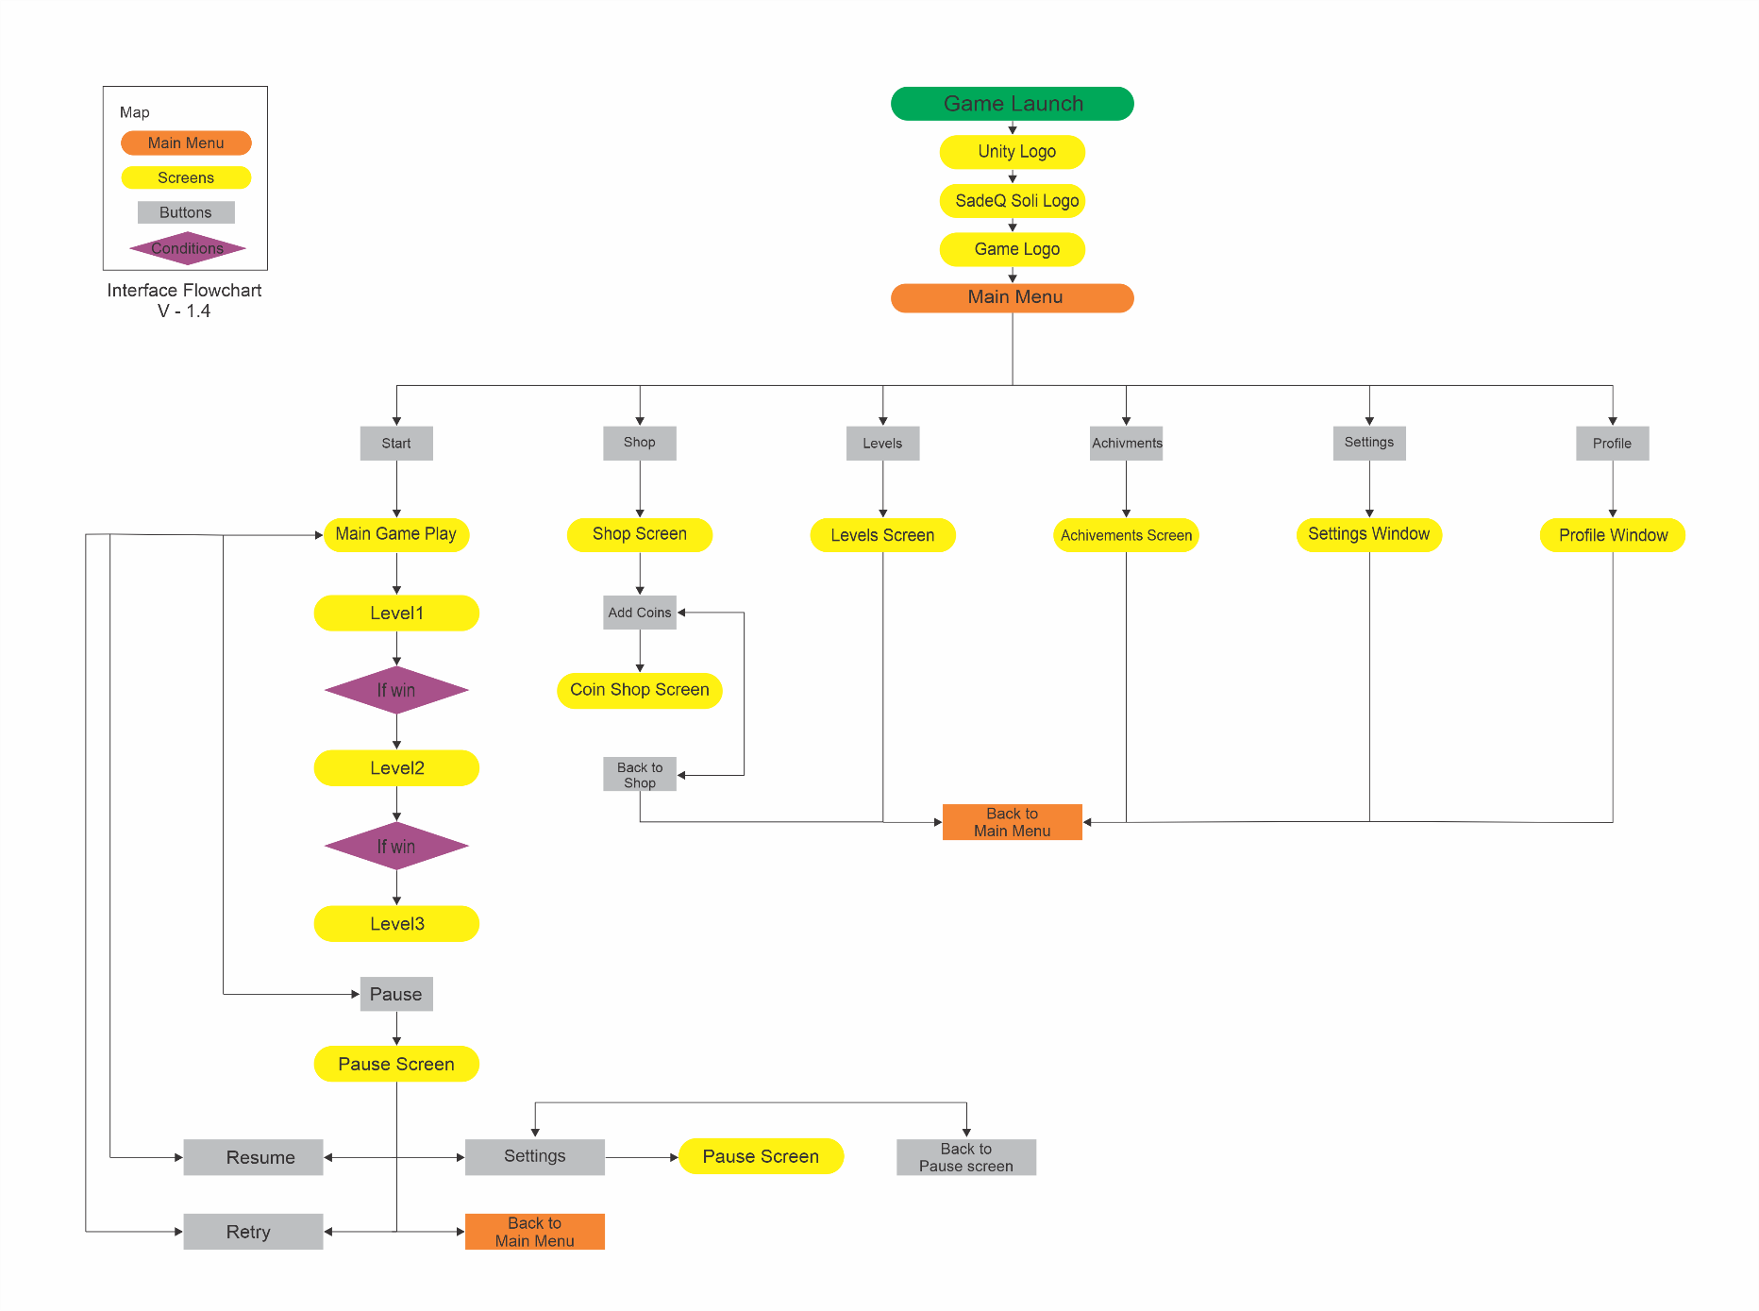

In-Game Elements

This screenshot shows the elements that the interface essentially has.

TODO: Picture of Win/Game Over Screen.

**Game Screen**

→ Where all the game play takes place in.

**Characters**

→ The player’s food.

→ The Insects.

**Movement in game play**

→ player will not move.

→ swatter will be positioned where that player touch on the screen.

→ Insects are moving towards the food.

→ Player might be able to move the food to protect it.

**Pause Button**

→ Pause button at the top/right of screen to show up pause panel.

**Mute Button**

→ For muting all of sounds and music at once in the gameplay.

**Health Bar**

→  Shows how much Energy the player arm has left.

**Score Bar**

→  Shows how much score the player (Resisted) has collected.

**Swatter Bar**

→  Shows how much the player (swatter’s life) has left.

**Time Bar**

→  Shows how much time the player has left to win.

**Subtitle**

→ Enforces what the NPC or Player said.

**Power Down**

→ player should avoid it to stay safe.

**Powerup**

→ player should collect these to get more powerful.

Characters

**The Player => Captain <Username>**

→ This is the character that going to conquer the pirates and their fleet.



**The Insect#1 => Captain Francis Spriggs (Dragon of the Sea)**

→ This is the character that going to conquer the pirates and their fleet.



**The Insect#2 => Captain Edward Low (Ned Low)**

→ This is the character that going to conquer the pirates and their fleet.



**The Insect#3 => Captain Anne Bonny (Pirate Queen)**

→ This is the character that going to conquer the pirates and their fleet.



**The Insect#4 => Captain Cheung Po Tsia (Black Swan)**

→ This is the character that going to conquer the pirates and their fleet.



**The Insect#5 => Captain George Lowther (The Dragon)**

→ This is the character that going to conquer the pirates and their fleet.



**The Insect#6 => Captain Calico (Pirate King)**

→ This is the character that going to conquer the pirates and their fleet.



The Stage Difficulty

So to understand the stage system of this game, we should know every stage is a war against on of the evil pirates and every stage has 24 levels. That means every level is a battle to win the war. So to win “ the great war ” player should win every battle and every war against these evil pirates. There are 288 levels divided by 12 stage of 24 level. (12 * 24 = 288)

For example:

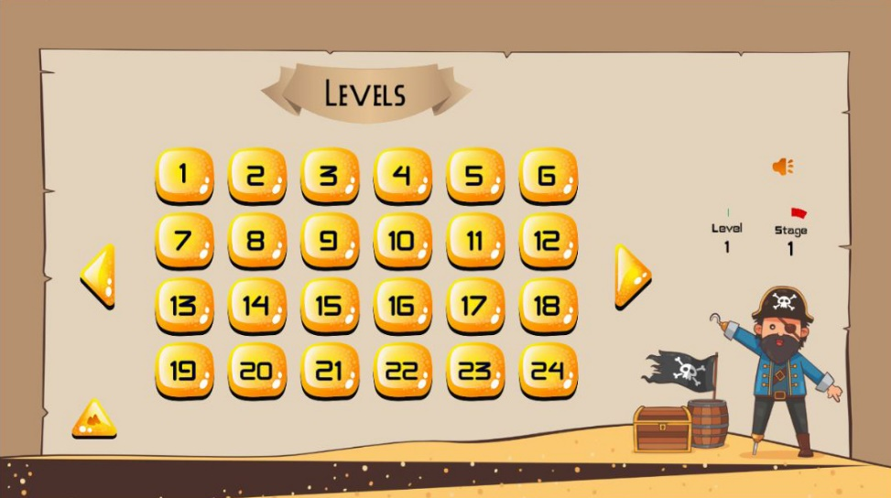

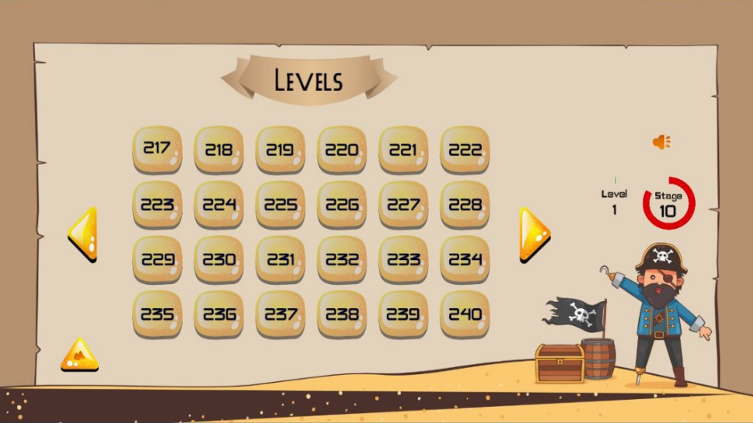

# Assets Needed

## 2D

Textures

* + Water 2D
  + Sea Wave 2D

Characters List

* + Captain <Username> #1
  + Captain #2
  + Captain #3
  + Captain #4

Environmental Art Lists

* + Example #1
  + Example #2
  + Example #3
  + Example #4

Sound List (Ambient)

**Outside**

* + - Example #1
    - Example #2
    - Example #3
    - Example #4

**Inside**

* + - Example #1
    - Example #2
    - Example #3
    - Example #4

Sound List (Player)

**Character Movement Sound List**

* + - Example #1
    - Example #2
    - Example #3
    - Example #4

**Character Hit / Collision Sound List**

* + - Example #1
    - Example #2
    - Example #3
    - Example #4

**Character Injured / Death Sound List**

* + - Example #1
    - Example #2
    - Example #3
    - Example #4

Scripts

* + - Example #1
    - Example #2
    - Example #3
    - Example #4

**Character Scripts (Player Pawn/Player Controller)**

* + - Example #1
    - Example #2

**Ambient Scripts (Runs in the background)**

* + - Example #1
    - Example #2

**NPC Script**

* + - Example #1
    - Example #2

Animation

**Environment Animations**

* + - Example #1
    - Example #2
    - Example #3
    - Example #4

**Character Animations**

* + - Player
* Example #1
* Example #2
* Example #3
* Example #4
  + - NPC
      * Example #1
      * Example #2
      * Example #3
      * Example #4

## 3D

Effects

* + Explosion

## Fonts

English

* + Font #1
  + Font #2
  + Font #3
  + Font #4

Persian(Farsi)

* + Font #1
  + Font #2
  + Font #3
  + Font #4

# Schedule

## Version 1.0.0

Time Scale

* Milestone 1
* Milestone 2
* Etc.

## Version 1.0.1

Time Scale

* Milestone 1
* Milestone 2
* Etc.

## Version 1.0.2

Time Scale

* Milestone 1
* Milestone 2
* Etc.

## Version 1.0.3

Time Scale

* Milestone 1
* Milestone 2
* Etc.

## Version 1.0.4

Time Scale

* Milestone 1
* Milestone 2
* Etc.

## Version 1.0.5

Time Scale

* Milestone 1
* Milestone 2
* Etc.

## Version 1.0.6

Time Scale

* Milestone 1
* Milestone 2
* Etc.

## Version 1.0.7

Time Scale

* Milestone 1
* Milestone 2
* Etc.